Mongodb Task:

1. Creating database product
2. Creating collection

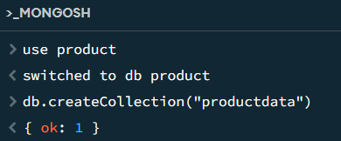

1. Inserting data

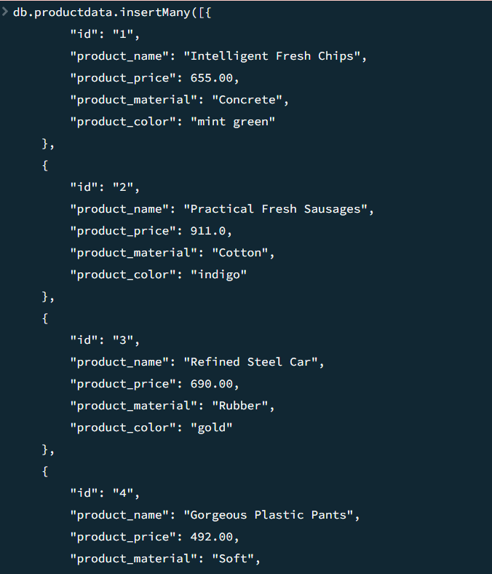

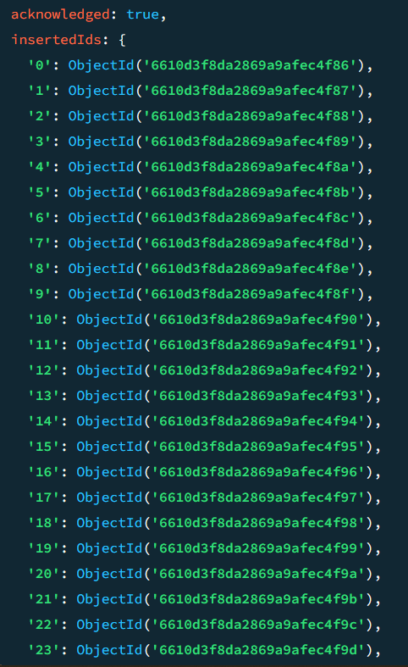

1)Find the all the information about each products

Answer:

* db.collectinname.find({})
* db.productdata.find({})

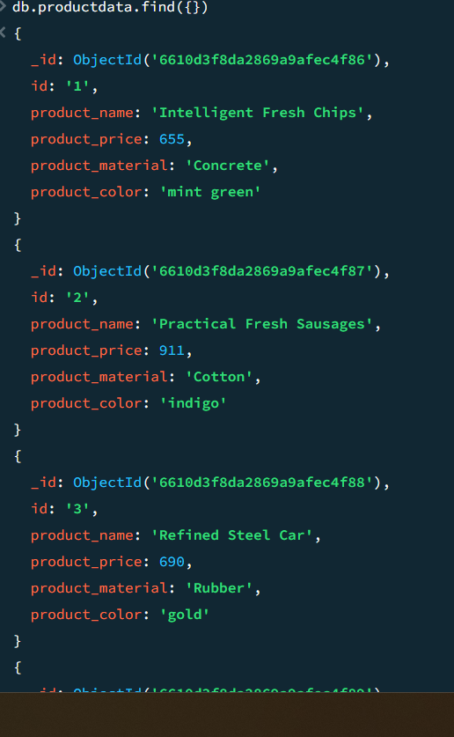

2)find the product price which are between 400 to 800

Answer:

db.productdata.find({product_price:{$gte:400,$lte:800}})

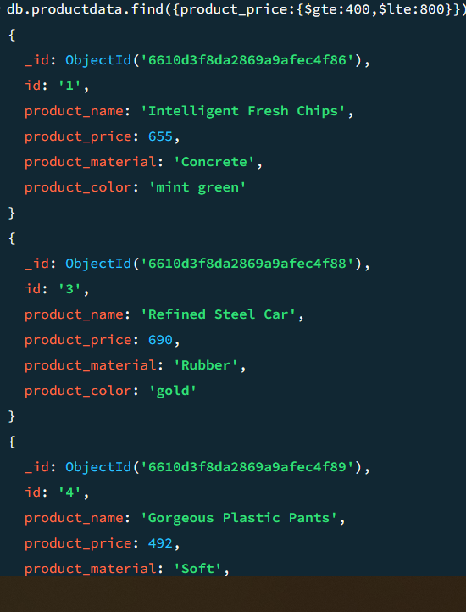

3) find the product price which are not between 400 to 600

Answer:

db.productdata.find({product_price:{$not:{$gte:400,$lte:600}}})

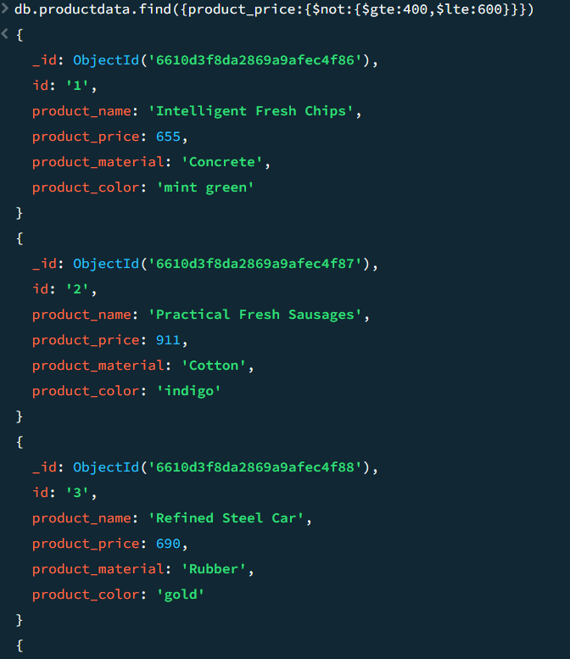

4)List the four product which are greater than 500 in price?

Answer:

db.productdata.find({ product_price: { $gt: 500 } }).limit(4)

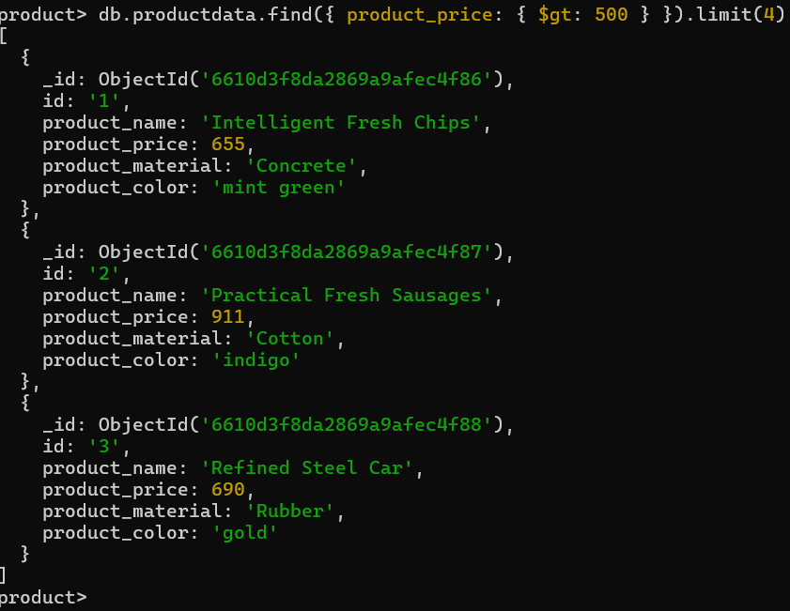

5)find the product name and material of each product?

Answer:db.productdata.find({},{product_name:1, product_material:1 })

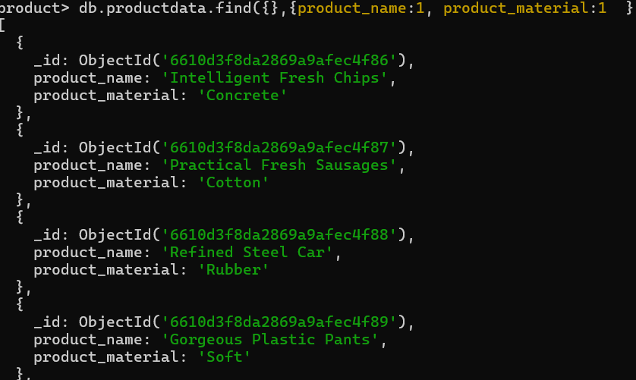

6)find the product with row id 10?

Answer: db.productdata.findOne({ _id: ObjectId("6610d3f8da2869a9afec4f8f") })

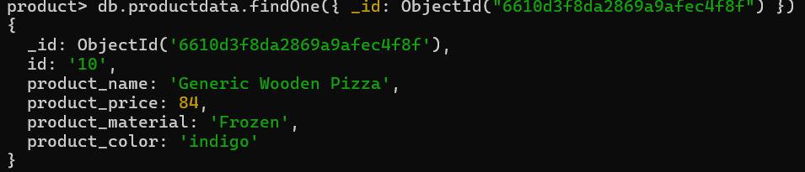

7)find only the product name and metrial?

Answer: db.productdata.find({}, { _id: 0, product_name: 1, product_material: 1 })

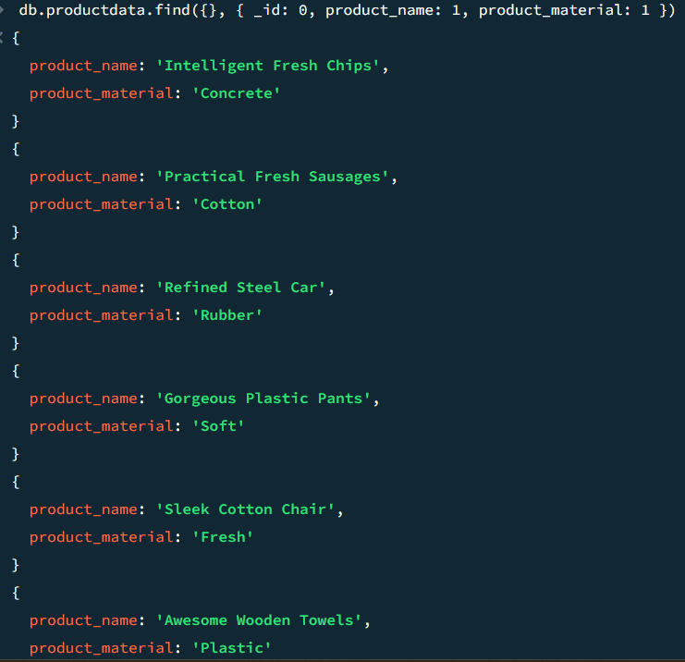

8)find the all the product which contain the value of the soft inproduct material?

Answer: db.productdata.find({ product_material: { $regex: /soft/i } })

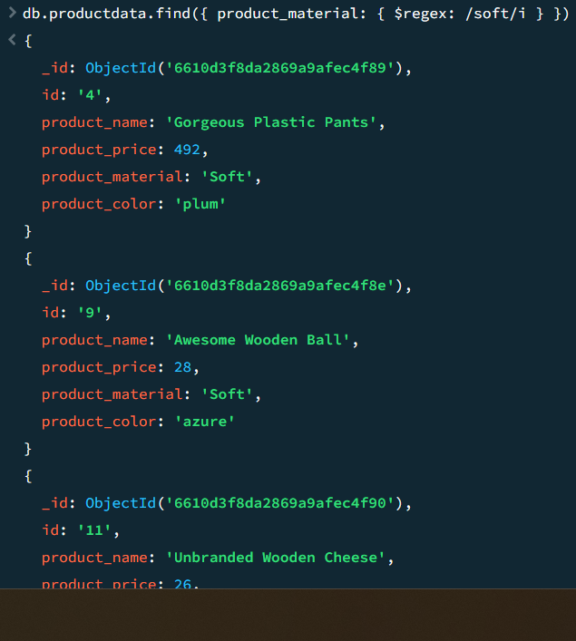

9)find product which contains product color indigo and price 492.00

Answer: db.productdata.find({ product_color: "indigo", product_price: 492.00 })

10)Delete the product which product price value are 28

Answer: db.productdata.deleteOne( { product_price: **28** } )

